Lesson 5: How does changing the mass or speed of a moving object before it collides with another object affect the forces on those objects during the collision?

Previous Lesson | We planned and carried out an investigation into the relationship of contact force applied and the amount of deformation that occurs in different materials. We graph our data and compare them to graphs from other materials tests. We developed a model to explain and represent the elastic and nonelastic behavior of all solid objects in response to varying amounts of force applied to them.
This Lesson  Investigation  2 days   |  | We carry out investigations to explore the strength of forces between two objects when they collide. We plan and carry out an investigation about how different speeds and masses of objects affect the amount of peak force on each object. We develop and use a model to represent the relationship between the energy of a moving object and the strength of the peak forces from a collision.
Next Lesson | We will look back at questions from our Driving Question Board and answer questions we have made progress on during Lesson Set 1. We will take an assessment to apply our science ideas to a new context and will determine we need to figure out what causes more damage and energy transfer during a collision--increases in mass or increases in speed.

BUILDING TOWARD NGSS  MS-PS2-1, MS-PS2-2, MS-PS3-1, MS-ETS1-2, MS-ETS1-3, MS-LS1-8   | What students will do  5.A Plan and carry out an investigation and identify patterns in the data collected from the investigation to provide evidence that when peak contact forces on each object during the collision are equal in strength, the strength of those forces increases when the mass or the speed of the object that was moving before the collision increases.  5.B Develop and use subsystem models (free body diagrams) to represent how the peak contact forces on two different objects compare in a collision and how these are related to corresponding changes in the kinetic energy of a moving object before it collides due to an change in its mass or the speed.  What students will figure out  - Objects that make contact with each other apply equally strong forces on each other in opposite directions.  - Objects that collide apply an equally strong peak force (maximum force) on each other during the collision.  - A free body diagram can help represent the forces on the objects in a collision by considering each object separately.  - Increasing the speed or mass of a moving object increases its kinetic energy (KE).  - The more KE that objects in a system have, the higher the peak forces they can produce in a collision.

Lesson 5 • Learning Plan Snapshot
Part | Duration |  | Summary | Slide | Materials
1 | 5 min |  | NAVIGATION  Share predictions about forces between objects in collisions. | A
2 | 6 min |  | EXPLORING FORCE INTERACTIONS WITH FINGERS | B-C
3 | 10 min |  | INVESTIGATING WITH PUSH-PULL SPRING SCALES  Investigate how push-pull spring scales can help us see how the forces compare when two objects gently push or pull on each other. | D-E | Comparing Forces on Two Push-Pull Spring Scales, 2 5-N push-pull spring scales, 1 S hook, 2 sticky notes, 1 marker
4 | 12 min |  | MAKING SENSE OF THE RESULTS AND TESTING FORCE INTERACTIONS BETWEEN DIFFERENT-STIFFNESS SPRINGS  Make sense of how push-pull spring scales can help us see how the forces compare when two objects gently push on each other. | F | 2 5-N spring scales, 1 10-N spring scale, chart paper, markers
5 | 8 min |  | PLANNING OUR NEXT INVESTIGATION  Plan an investigation to collect data for different collision conditions. | G-H | Lesson 5: Independent, Dependent, and Controlled Variables, chart paper, markers, transparent tape
6 | 3 min |  | INTRODUCE THE READING  Orient to the reading that is related to finding out more about our fingers and other parts of our bodies that are able to detect forces applied to them. |  | Reading: How does touch work?

End of day 1
7 | 5 min |  | NAVIGATION  Share new insights from the reading. Review what investigation question each group is going to plan for and carry out and what led us to want to investigate these questions. | I | Lesson 5: Independent, Dependent, and Controlled Variables, Object Interactions During A Collision
8 | 8 min |  | PLANNING OUR INVESTIGATIONS  Identify variables for the investigation and prepare a data table to record the results. | J-K | Lesson 5: Independent, Dependent, and Controlled Variables, https://youtu.be/HRYcfOPCoRo, computer, projector
9 | 10 min |  | INVESTIGATING FORCE INTERACTIONS WITH DIFFERENT SPEEDS AND MASSES  Carry out the Peak Force Collision Investigation. | K | Lesson 5: Independent, Dependent, and Controlled Variables, impact goggles, Peak Force Collision Investigation
10 | 4 min |  | INDIVIDUAL PROGRESS TRACKER UPDATE  Record and share what students figured out related to the lesson question in their individual Progress Tracker. | L
11 | 15 min |  | REVISE OUR CLASS CONSENSUS MODEL IN A SCIENTISTS CIRCLE  Develop a classroom consensus model to represent the results in terms of changes in the mass and speed of objects in the system and the resulting changes in the peak forces between the colliding objects. | M | colored pencils (black red blue green orange and purple), Contact Force Interactions poster, chart paper, colored markers (black, red, blue, green, orange, and purple)
12 | 3 min |  | EXIT TICKET  Use the consensus model to explain how the strength of the forces between a falling phone and the ground would compare for three different scenarios. | N | scrap paper

End of day 2

Lesson 5 • Materials List
 | per student | per group | per class
Peak Force Collision Investigation materials |  | - 1 aluminum track secured to lab table with painters tape  - 2 5-N spring scales attached to 2 carts with hook and loop fasteners  - 1 twist tie collar on each spring scale plunger  - 6 washers  - 4-5 grams of modeling clay
Lesson materials | - Comparing Forces on Two Push-Pull Spring Scales  - science notebook  - Lesson 5: Independent, Dependent, and Controlled Variables  - Reading: How does touch work?  - Object Interactions During A Collision  - impact goggles  - colored pencils (black red blue green orange and purple)  - scrap paper | - 2 5-N push-pull spring scales  - 1 S hook  - 2 5-N spring scales  - 1 10-N spring scale | - 2 sticky notes  - 1 marker  - 2 5-N push-pull spring scales  - 1 S hook  - chart paper  - markers  - transparent tape  - https://youtu.be/HRYcfOPCoRo  - computer  - projector  - Contact Force Interactions poster  - colored markers (black  - red  - blue  - green  - orange  - and purple)

Materials preparation (45 minutes)

Review teacher guide, slides, and teacher references or keys (if applicable).

Make copies of handouts and ensure sufficient copies of student references, readings, and procedures are available.

Test the video link to make sure it is working:
- https://youtu.be/HRYcfOPCoRo
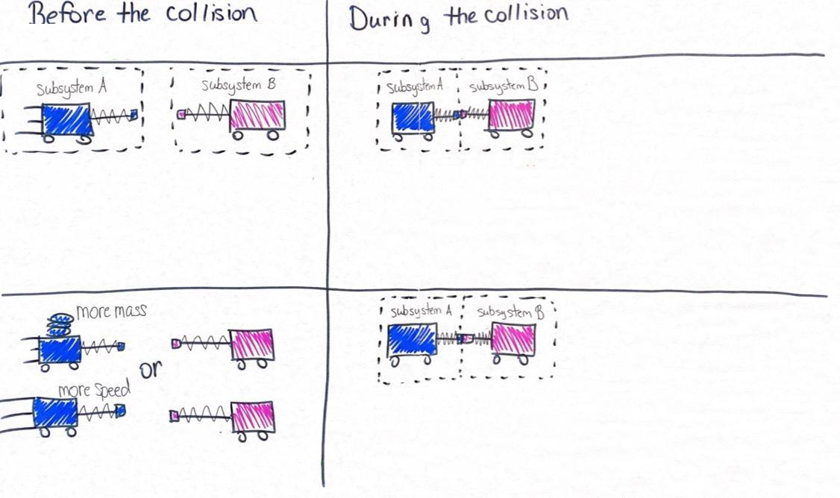
Make a Contact Forces Interaction poster using two pieces of chart paper for representing the two subsystems in the system (the two carts with spring scales on them) as shown to the right.

Day 1: Spring Scale Investigations
- Group size: 6 groups of 3-4
- Setup: Set aside two 5-N push-pull spring scales and one 10-N push-pull spring scale and one S hook per group (these hooks are removed from the 5-N push-pull spring scales during the preparation described in Spring scale and cart modifications and setup).
- Safety:
- Wear safety goggles or glasses during the setup, hands-on, and take-down segments of the activity.
- Never eat any food items used in a lab activity.
- Make sure all other fragile items are removed from the test area.
- Secure loose clothing, remove loose jewelry, wear closed-toe shoes, and tie back long hair.
- Immediately pick up any items dropped on the floor so they do not become a slip/fall hazard.
- Follow your teacher’s instructions for disposing of waste materials. Wash your hands with soap and water immediately after completing this activity.
- Storage: All materials can be stored and reused indefinitely.

Day 2: Peak Force Collision Investigation
- Group size: 6 groups of 3-4
- Setup: See Spring scale and cart modifications and setup for directions on how to prepare the spring scales for day 2 of the lesson. The preparation of the spring scales and stations will take 30 minutes of the total preparation time for this investigation.
- Safety:
- Wear safety goggles or glasses during the setup, hands-on, and take-down segments of the activity.
- Never eat any food items used in a lab activity.
- Make sure all other fragile items are removed from the test area.
- Secure loose clothing, remove loose jewelry, wear closed-toe shoes, and tie back long hair.
- Immediately pick up any items dropped on the floor so they do not become a slip/fall hazard.
- Follow your teacher’s instructions for disposing of waste materials. Wash your hands with soap and water immediately after completing this activity.
- Storage: All materials can be stored and reused indefinitely.

Lesson 5 • Where We Are Going and NOT Going

Where We Are Going

In day 1 students figure out that it takes two objects to create a force and that forces come in pairs. When two objects touch, the first applies a force on the second and the second applies a force on the first. They then use spring scales to figure out that these forces have the same strength. Finally, in their investigations on day 2 students will figure out that during a collision the forces on each object are the same strength but opposite in direction, regardless of the speed of the objects and the masses of the objects in the collision. They will connect this outcome and the results that different groups produced to identify two causes for increases in the peak forces on both objects in a collision. One of these is an increase in the mass of a moving object, the other is an increase in the speed of a moving object, and both of these lead to an increase in kinetic energy of the object. The generalized understanding that students develop of the connection between energy and forces is that the more kinetic energy that objects have, the higher the peak forces they can produce in a collision with another object.

This lesson leverages student experience with planning an investigation elicited in the previous lesson. In that lesson, as in this one, they identified an independent and a dependent variable and variables to keep constant. A standard handout for planning an investigation and identifying variables was introduced for the first time in this grade band in the previous lesson. But that handout is one that they have used in prior grade OpenSciEd units. The structure of that handout is the same as the one they are using in this lesson: Comparing Forces on Two Push-Pull Spring Scales. That should help make the investigation planning in this lesson a familiar process.

This lesson leverages students’ prior thinking about systems elicited at the end of Lesson 2, where the class develops a system model similar to the one they are drawing now where one part of the system model was taking an energy perspective view of the phenomenon and the other part of the system model was taking a force interaction view of the phenomenon. You may want to refer to the Lesson 2 model at the end of this lesson. In future lessons you will want to refer to the system model you develop on chart paper at the end of this lesson.

In physics and engineering, a free body diagram is a graphical illustration used to visualize the applied forces on a body or object in a given condition. In such diagrams, the object is often represented as a box (or dot) and the forces acting on it are shown as straight arrows pointing in the direction they act on the body. Students will be introduced to standard conventions for representations for the external forces on that object that include the following:
- The direction of the force arrow indicates the direction of the force applied on the object.
- Differences in length of an arrow represent differences in the relative magnitude of a force.
- The tip of the arrow indicates the surface on which the contact force pushes.

There is an important reading for students to do before Lesson 6. It introduces students to how the sense of touch works and how this is connected to other structures that relay information to and from the brain. It is designed to be assigned as home learning at the end of day 1 of this lesson. In the reading students will be introduced to the structure of neurons and a substructure of these cells: axons. In Lesson 6, they connect the structure and function of axons to ideas they have developed about breaking point, contact forces, and kinetic energy to explain phenomena related to concussions in sports (and likely sources of it). This is one of many readings in the OpenSciEd program that are spread across multiple units and are designed to target different parts of ideas related to MS-LS1-8.

Where We Are NOT Going

Students will not be using free body diagrams to represent coordinate systems since the grade-band focus of forces should be limited to the study of forces in one dimension.

We will not explore the amount of force required to change the motion of an object a certain amount. This will be explored in Lesson 7.

At the end of the lesson the class develops the idea that the more kinetic energy an object in a system has, the higher the peak forces it can produce in a collision with another object. The word “can” is an important qualifier since this relationship holds true for any collision where one object is motionless before the collision and the other object moves into it. It also holds for when two objects move toward each other head-on in a collision. The case where it doesn’t hold true is where both objects are moving in the same direction. For example, if both object A and object B are moving to the right and object A is catching up to object B, then any increase in the speed of object B that keeps the speed of object B less than that of object A will result in a collision between them that reduces the peak forces between them. This case is not one students will encounter in lesson activities in this unit and therefore not worth introducing.

LEARNING PLAN for LESSON 5
1 · NAVIGATION | 5 min
MATERIALS: None
Reintroduce the questions students were considering at the end of the last lesson. Say, We’ve been using forces to explain deformation of objects in a collision or any time they make contact. So let’s consider some of the cases we’ve looked at before using this force perspective. Show slide A. Give students a moment to reread the text on the slide. Then say, What did you and your partner predict about these two different cases? Were you in agreement or did you have different ideas?

Share ideas about forces between objects in a collision. Anticipate some disagreement in students' responses. Encourage students to weigh in on the ideas that are shared so you can help students recognize that we are either not in agreement or we are uncertain about some of our predictions and need additional evidence to support alternate ideas.

Suggested prompt | Sample student response
In each collision, what is doing the pushing and what is getting pushed? | In the golf ball and golf club case, the force is only on the golf ball, not on the club. The club is the thing moving, so it is the only thing pushing. It is pushing on the golf ball.  I think that both the golf club and the golf ball are getting pushed. Even if we can’t see the club face bending, I think the stem of the club bends, and you would feel it getting pushed too. So I think both the ball and the club get pushed during the collision.  In the baseball and bat case, you can feel the bat get pushed when you hit a ball. Sometimes the bat even breaks when a really fast pitch hits it, which must mean it got pushed beyond its breaking point.  We saw both the ball and the bat get deformed in the video even when the bat was motionless and the ball was moving.
So what happens when something like a phone falls and hits the ground and breaks? The two objects are the phone and the ground--what’s pushing on what? | The phone pushes on the ground.  The ground pushes on the phone
We figured out that for an object to break, it needs a force applied to it that deforms it beyond its elastic limit. So if you drop a phone and it breaks when it hits the floor, what could be pushing on the phone? | I don’t know!  Maybe the floor?  Maybe there is something we can’t see pushing on the phone. Maybe it’s the phone pushing on itself?

Say, It seems like figuring out what is pushing on what is something we need to resolve in order to explain why some things break and others don’t in a collision. Let’s look more closely at the interactions between two objects to see if we can figure out what is getting pushed in a collision. Maybe if we start by thinking about where the force is occuring during a collision, that will help us make progress on figuring out what is getting pushed and what is doing the pushing.

2 · EXPLORING FORCE INTERACTIONS WITH FINGERS | 6 min
MATERIALS: None
Begin the exploration of force interactions between two objects. Say, Let’s start our investigations with our own built-in force sensors: our fingers.  Show slide B and instruct students to follow the directions on the slide either on their own or in tandem with a partner if they want to do so. Don’t take time to have students report out their results to the whole group yet though.  After everyone has completed these steps, which should take under 2 minutes, say, We can use our fingers as a force sensor in a different way too. Prompt students for an additional line of evidence we can use to determine that forces are being applied to any object.  Suggest that we repeat the investigation again but that this time we look for deformation of our fingertips to determine which fingertip is getting pushed on when they make contact with each other.  Show slide C and instruct students to follow the directions on the slide either on their own or in tandem with a partner if they want to do so. After everyone has completed these steps, which should take under 2 minutes, bring students together to discuss the results. Encourage students to look at what their fingers are doing again as they talk through these questions. | ✱ ATTENDING TO EQUITY  If you have a student with a physical disability who can’t use fingers for this activity, revise the instructions to include the option to use other parts of their body, such as their knees or elbows, to feel forces. Or if they are not able to do any of these, they could do the activity with a partner at any place on their body that is appropriate for them to interact with and report that they can detect feeling (e.g., on their chin or forehead).
  Suggested prompt | Sample student response
  What have we figured out will happen to the shape of any solid when we apply a contact force to it? | It should deform.
  Suggested prompt | Sample student response
  Did you feel or see any push on your fingertips when they are not making contact with each other? | No.
  Where did you feel a push or force on your fingertips when you tried this? On only one of the fingertips or both? | I felt a push (force) on both my left and right fingertips.
  So, we only detect a force when our two fingers are touching, and we don’t feel a force on either of them when they are not touching. How does this compare with where we saw evidence of deformation? Did we see only one fingertip deform or both when they touched each other? | Both fingertip surfaces deformed.
  What was it that was applying the force on your left finger? | Our right finger.
  What was it that was applying the force on your right finger? | Our left finger.
  When you pushed harder with either fingertip how did that affect the amount of deformation on each? | Both fingertip surfaces deformed more.
  What can we say about the direction of the forces on each finger? Are they in the same direction or in opposite directions? | The forces seem like they are in opposite directions.
  How do you think the forces compare? Is one stronger than the other? What is your evidence? | It’s hard to say how the forces compare.  It feels like they might be the same.  The amount of deformation of my fingertips appears to be about the same, so maybe the forces are the same.

3 · INVESTIGATING WITH PUSH-PULL SPRING SCALES | 10 min
MATERIALS: Comparing Forces on Two Push-Pull Spring Scales, 2 5-N push-pull spring scales, 1 S hook, 2 sticky notes, 1 marker
Ask for ideas for how we could measure and compare the amount of force on objects that make contact. Say, OK, so we can see evidence of forces on both objects that make contact with each other when we use our fingers as force detectors. But our fingers have some limitations in terms of comparing the amount of force on them. Though we can try to say whether we feel or see evidence of more or less force on them, they don’t provide an exact measurement of the strength of the forces applied to them. What tools have we used in previous investigations to help us get a more-exact measurement of the strength of the force being applied to an object? Students will say the spring scales.

Say, Let’s use those again to investigate how the strengths of contact forces compare. First we’ll make some predictions for what the spring scales would show if we pushed them against each other or hooked them together and pulled them apart . Distribute Comparing Forces on Two Push-Pull Spring Scales. Show slide D. Give students about 2 minutes to complete their predictions.

ALTERNATE ACTIVITY | It is assumed that the photos on slide D will be adequate for helping students visualize what it will look like as they push the plunger ends of spring scales together and what it will look like as they pull the hooked ends of them apart. As an alternative, however, you could demonstrate how they will use the spring scales by holding up two 5-N push-pull spring scales as manipulatives. If you do this, put a sticky note labeled “A” on one and a sticky note labeled “B” on the other. This labeling is used in student handout for the next investigation to refer to one spring scale vs,. The other.. Demonstrate bringing them toward each other, stopping short of actually making contact between them as you don’t want to give away the results from the investigation they are about to do. Demonstrate looping an S hook through the opening on both twisted wire ends of the push-pull spring scales to do the pull investigation.

Have groups carry out the investigation steps summarized on slide E. It should take no more than five minutes for groups to get their spring scales and S hook, carry out their investigation, and record their results.

4 · MAKING SENSE OF THE RESULTS AND TESTING FORCE INTERACTIONS BETWEEN DIFFERENT-STIFFNESS SPRINGS | 12 min
MATERIALS: 2 5-N spring scales, 1 10-N spring scale, chart paper, markers
Ask students to push their spring scales away from them to the center of the table while the class has a brief discussion.

Suggested prompt | Sample student response
What did your results show you about how the strength of the forces on each object compare when two objects make contact with each other? Are those forces the same strength or different? What evidence supports your claim? | The forces are the same on each object. As we look across our data table, we see that the amount of force was the same in every single case.

Help students summarize their findings across the two investigations.

Suggested prompt | Sample student response
Can one object apply a force on another object without the other object applying a force back? | No, it seems that if one object applies a force, the other object applies a force back. It didn’t matter which one was doing the pushing in the cases of the fingers or the spring scales.
So what then is the minimum number of objects you need in order to produce contact forces? | It seems like you need at least two objects.
Did every object we tested deform when a contact force was applied to it? | Yes.
So if all objects are elastic up to a point and we know that even a small amount of force causes objects to bend some, why don’t we see all objects visibly deform even when other things make contact with them? | Some objects are stiffer than others.  They deform such a small amount it is hard for us to detect it.

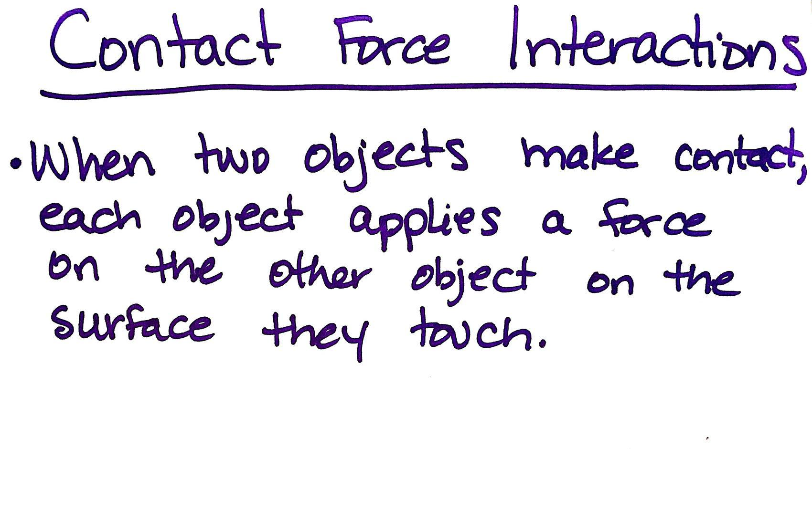
Say, Let’s summarize what we’ve figured out. Add this idea to a poster titled “Contact Force Interactions”:
- When two objects make contact, each object applies a force on the other object on the surface they touch.

Introduce another case to consider. Say, OK, so we know that all objects are elastic up to a point. When we made contact between two of the same type of object, two fingers or two spring scales, we found that they always pushed back or pulled back with equal strength on each other. But we also know that not all objects have the same level of springiness. Some deform a lot and some deform relatively little for the same amount of force applied to them. I have some spring scales that are like that too. Let’s see how we can use those to explore how the forces compare when objects with different springiness push on each other.

Make predictions. Say, Let’s get ready to use these different spring scales to test what would happen to the forces between any two objects when they make contact with each other, even when those objects have a different elasticity.

Describe how a 5-N vs. 10-N spring scale deforms when the same force is applied to them. Show slide F. Have students discuss predictions with their group, related to the question on the slide:
- How will the forces on each spring scale compare when you push them against each other?
As they are doing this, distribute one 10-N spring scale to each group.

Test predictions. Once all spring scales are distributed, instruct students to take a couple of minutes to test their predictions they discussed from the previous question. by pushing one 5-N spring scale against the 10-N spring scale.

After a couple of minutes, ask students to push their spring scales away from them to the center of the table while the class has a brief discussion. Refer to the Contact Force Interactions poster and ask if the statement on it was supported or refuted by the evidence collected from this investigation and what new ideas we can add to it.

Suggested prompt | Sample student response
Earlier, we said that when two objects make contact, one object applies a force on another object and the other object applies a force back. Did that happen in this investigation even when the objects have different stiffness or elasticity? | Yes.
What did your results tell you about the strength of the forces on each object when two objects make contact with each other? Are they the same strength or different? | The forces are the same on each object.
Are these forces in the same direction or in opposite directions? | Opposite directions.
So what new idea could we add to this poster we started about contact force interactions? | The strengths of the contact forces are the same but in the opposite direction.

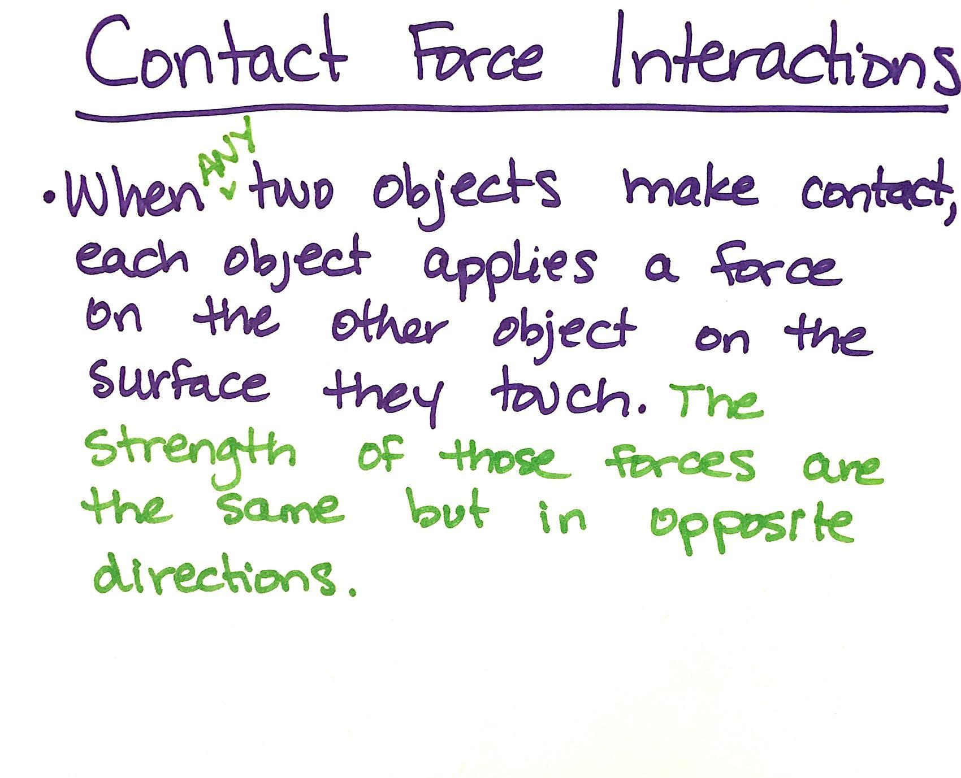
Add this idea to the Contact Force Interactions poster by revising the statement that is already there. Then add the second statement to the poster:
- When any two objects make contact, each object applies a force on the other object on the surface they touch. The strengths of those forces are the same but in the opposite directions.

5 · PLANNING OUR NEXT INVESTIGATION | 8 min
MATERIALS: science notebook, Lesson 5: Independent, Dependent, and Controlled Variables, chart paper, markers, transparent tape
Motivate an investigation about whether these generalizations hold true with collisions. Say, We’ve seen support for these ideas when we are holding the objects and applying a gentle push or pull to them. But do these ideas still hold true when we have collisions? Would the same equal forces on both objects happen when something is moving without us holding onto it and it collides into something else? Would changing anything about the moving object affect the forces between the two things when they make contact? Let’s brainstorm some different collision conditions that we could possibly test with these carts.

Show slide G. Give students a minute to orient to the setup shown on the slide and then think on their own about the question on the slide before discussing it as a class.

Suggested prompt | Sample student response
What are some different collision conditions that we could possibly test with these carts? | We could change  - if one cart is moving or if both are moving  - if one cart is going slow or fast, or  - if one cart is really heavy or light.

Write student responses on a piece of chart paper and title it “How do forces on two colliding objects compare when we change … ?”. Guide students to think about 2 different cases: changing how fast the carts move and changing the mass of the carts.

ADDITIONAL GUIDANCE | Students may come up with changing the material; at this point, that is OK. Since they already looked at this by seeing what happens when they use two push-pull spring scales of different stiffness, you can argue that rather than immediately pursuing more investigations related to this variable in the next day of the lesson, we can return to it in future lessons (e.g., after Lesson 9) and now should try to make progress on the two variables they identified that we haven’t investigated yet (mass and speed).

Say, Let’s start planning to collect data to investigate these two variables. Ask students about what challenges they anticipate in data collection and investigation design.

Suggested prompt | Sample student response
What are some challenges you anticipate in collecting data so that you can compare the amount of force on two different spring scales on two different carts when you collide the two carts together under these different conditions? | It is going to be hard to read the spring scales during the collision because at least one of them will be moving before the collision.  The collision happens so quickly that it will be hard to read the amount of force on both spring scales during that brief period of time.  It could be hard to keep some things constant between different conditions. For example, it might be hard to ensure that we are colliding two carts together at the same speed if what we are trying to change is just the mass.

Say, These are all important challenges to consider in your investigation design, along with how much data you will need to collect to be certain of your findings, since we know when there are potential sources of error, more data makes us more certain of what we can conclude. Since we have two different variables to investigate as a class, we need some groups to investigate how changing speed of a moving object before it collides with another object affects the forces on both objects during the collision, and we need other groups to investigate how changing the mass of a moving object before it collides with another object affects the forces on both objects during the collision.

Write these two investigation questions at the bottom of the chart paper titled “How do forces on two colliding objects compare when we change … ?” and label each with a letter:
- How does changing the speed of a moving object before it collides with another object affect the forces on those objects during the collision?
- How does changing the mass of a moving object before it collides with another object affect the forces on those objects during the collision?

Distribute Lesson 5: Independent, Dependent, and Controlled Variables. Show slide H. Assign half the class (three groups of 3-4 students) one of these questions to investigate and the other half of the class (three groups of 3-4 students). the other question. Instruct students to record the question they have been assigned on their handout and tape the handout into their notebooks.

6 · INTRODUCE THE READING | 3 min
MATERIALS: Reading: How does touch work?
Revisit using fingers as force detectors in prior investigation. Say, You have used your fingers as force detectors today. Other places on us can detect contact forces against the skin too. Take a moment to touch the tip of your finger to the following: your forehead, your cheek, and your elbow. Pay attention to which of these seems most sensitive to being able to detect something touching it. Give students a moment to do this as you distribute Reading: How does touch work? to each student.  Summarize the focus of the reading. Explain that the home learning will give us more information about how our sense of touch works and how this connects to what students figured out about neurons in (material.cl). | ✱ ATTENDING TO EQUITY  Universal Design for Learning: The ideas presented in this reading can be conceptually challenging for some students, so having different modes for interacting with the reading will provide different ways to access the reading. Some students may benefit from having this reading available as an audio reading so they can listen as they read along on the handout. Other students may benefit from doing a partner reading. Some students may benefit from expressing their understanding by annotating and adding to the existing diagrams in the reading rather than drawing a new body system diagram from scratch as is prompted at the end of the reading.
  ADDITIONAL GUIDANCE | This is an important reading for students to do before lesson 6, as they will encounter diagrams representing the structure of neurons and damage to neurons as part of a related collision phenomenon that they will explain in the individual assessment. This reading leverages prior work students did in OpenSciEd Unit 6.6: How do living things heal? (Healing Unit). In Lesson 6 (the next lesson), they connect the structure and function of axons to ideas they have developed about breaking point, contact forces, and kinetic energy to explain concussions in sports and likely sources of it.

End of day 1

7 · NAVIGATION | 5 min
MATERIALS: science notebook, Lesson 5: Independent, Dependent, and Controlled Variables, Object Interactions During A Collision
Follow up on the home learning assignment. If you assigned Reading: How does touch work? as home learning, ask students to turn and talk with a partner and summarize the most interesting idea they uncovered in the reading. Have students turn in the reading for you to review their responses.

Identify what we are planning to investigate today and why. Show slide I. Give students a minute to look at Lesson 5: Independent, Dependent, and Controlled Variables in their notebooks to find which investigation question their group is going to plan for and think about what they predict. Then report these in a whole-class discussion as well as what led us to investigate how the forces compare in collisions.

Suggested prompt | Sample student response
What are different groups going to investigate? | Some of us are going to investigate how changing the speed of a moving object before it collides with another object affects the forces on both objects during the collision.  Some of us are going to investigate how changing the mass of a moving object before it collides with another object affects the forces on both objects during the collision.
If you put one of the carts in motion and keep one stationary, which things in the system will have kinetic energy and which will not? | The moving cart and the push-pull spring scale attached to it will have kinetic energy. The stationary cart and push-pull spring scale will not.
So, for groups that are investigating changes in speed, how do we predict that will affect the forces on both cart subsystems during the collision? | More speed will lead to stronger forces.
For groups that are investigating changes in the mass of the moving object, how do we predict that will affect the forces on both cart subsystems during the collision? | More mass will lead to stronger forces.
With this predicted increase in the strength of the contact forces, will the forces on both spring scales still remain equal in strength like in our other investigations, or will they shift to being unequal? | Accept all responses:  - If the object is moving fast enough or has enough mass it will probably push harder on the object it collides with than that object will push back on it.  - Maybe they still will be equal in strength, since that is what we saw in all of our previous investigations where we slowly collided two objects together.
How is investigating these variables connected to the ideas we’ve developed so far about why things sometimes get damaged when they hit each other? | All objects have an elastic limit and a breaking point. If the amount of force applied to an object exceeds this it can become permanently deformed (damaged).  We need to understand how these force interactions change in collisions where the speed or the mass of the objects involved in the collision change.

8 · PLANNING OUR INVESTIGATIONS | 8 min
MATERIALS: science notebook, Lesson 5: Independent, Dependent, and Controlled Variables, https://youtu.be/HRYcfOPCoRo, computer, projector
Introduce a peak force measurement device. Say, Before you design the rest of your investigation, I have one other device you can use to help you record a measurement of the maximum amount of force on the push-pull spring scales during the collision. It’s a simple twist tie collar that is wrapped on the plunger of the spring scale. Let me show you a video of how it works for a spring scale on a cart that collides with a brick. Show slide J.  Show https://youtu.be/HRYcfOPCoRo. Then ask students what they noticed happened to the twist tie collar and how this twist tie can help us measure the maximum amount of force applied during collision.  Say, This position of the twist tie collar can provide you a record of the maximum force or the peak force applied to the spring scale during a collision since each of the marks on the plunger beam corresponds to two of the marks on the newton side of the scale for the amount of force. Make sure to slide the collar back the first mark next to the scale (which is zero), after you record the result from a collision. Remember to develop a plan with your group that includes a method for how to control for different variables and a data table to record the peak force on the push-pull spring scale for each condition you test.  Review materials available and plan investigations. Show slide K. Say, The materials you have available are shown on this slide. Discuss with your group the variables you need to change and measure for your investigation and record them on Lesson 5: Independent, Dependent, and Controlled Variables. Everyone in the group should prepare a data table to record your results on the next page of your notebook as well as a space to make note of any challenges or any sources of error you notice in your investigation. Everyone in the group should have impact goggles ready to put on before going over to the lab area to carry out your investigation. | ✱ SUPPORTING STUDENTS IN ENGAGING IN PLANNING AND CARRYING OUT INVESTIGATIONS  In this investigation, students are now determining the independent and dependent variables they will be changing and keeping constant and recording them on Lesson 5: Independent, Dependent, and Controlled Variables. This is similar in structure to what they did in the previous lesson, but with less guidance. Students also plan their own data table. And they are asked to make note of any challenges or any sources of error they encounter in the investigation. This help motivates the later need for calibrating the system being used to collect data in the investigation they carry out in lesson 7.
  Suggested prompt | Sample student response
  What did you notice happens to the twist tie collar in the collision? | It got pushed out a certain distance along the plunger beam.
  What would happen to the twist tie collar if a stronger amount of force was applied to the spring scale during the collision? | It would get pushed further along the plunger beam.
  What would happen to the twist tie collar if a weaker amount of force was applied to the spring scale during the collision? | It wouldn’t get pushed as far along the plunger beam.
  ASSESSMENT OPPORTUNITY | Building towards: 5.A Plan and carry out an investigation and identify patterns in the data collected from the investigation to provide evidence that peak contact forces on each object during the collision are equal in strength and the strength of those forces increases when the mass or the speed of the object that was moving before the collision increases.  What to look/listen for  - Identification of a single independent variable: mass or speed  - Identification of the following dependent variables: the peak force measured on the push-pull spring scale on cart subsystem A and the peak force measured on the push-pull spring scale on cart subsystem B  - Identification of important variables to keep constant: If students identified mass as the independent variable then they should identify speed as an important variable to try to keep constant. If students identified speed as the independent variable then they should identify mass as an important variable to try to keep constant.  - A data table with results from at least two conditions tested (e.g., no additional mass vs. added mass or slower speed vs. faster)  - Peak forces measurements and/or equalities or inequalities noted for both push-pull spring scales for each condition tested  - Results from repeated trials for each condition (optional)  - Source(s) of error in the system (optional)  What to do: You may want to have groups check in with you before moving to their labs to collect data. This would allow you to determine if the group members have properly considered 1-4 before carrying out the rest of the investigation. Once all groups are collecting data, you can then attend to whether groups are correctly recording data for 5 and 6. If time is short you could assign something related to 7 as a home learning assignment or extension opportunity, along with a question asking about ways to redesign the system to improve its reliability in terms of generating consistent results, eliminating more of the human error, and/or better controlling for speed if mass is the independent variable. This may lead students to propose ideas that are similar to what is in the procedure for the first investigation in Lesson 7 and can give you an opportunity to assess student thinking around engaging another part of the practice of planning and carrying out an investigation: revising an experimental design.

9 · INVESTIGATING FORCE INTERACTIONS WITH DIFFERENT SPEEDS AND MASSES | 10 min
MATERIALS: Peak Force Collision Investigation, science notebook, Lesson 5: Independent, Dependent, and Controlled Variables, impact goggles
Monitor lab work. Keep slide K projected.

SAFETY PRECAUTIONS   | Check that all students are wearing protective goggles.

ADDITIONAL GUIDANCE | If your school allows cell phones or has student tablets that can record slow-motion video and students suggest taking slow-motion video of the results, you could encourage them to try to capture that data too.

10 · INDIVIDUAL PROGRESS TRACKER UPDATE | 4 min
MATERIALS: science notebook
Update individual Progress Trackers. Show slide L. Ask students to record in their Progress Tracker this question and what they observed before we reconvene in a Scientists Circle to identify patterns in data and summarize what we figured out:
- How does changing the mass or speed of a moving object before it collides with another object affect the forces on those objects during the collision?

Give students time to record their discoveries.

ADDITIONAL GUIDANCE | Go around and look at what students are writing in their Progress Trackers so you can determine if there are any lingering areas of disagreement or controversy about whether the forces are equal in every case tested. If so, you could use this video as an additional source of evidence to resolve any remaining uncertainty: https://youtu.be/qeO3Fj0Dpik.

11 · REVISE OUR CLASS CONSENSUS MODEL IN A SCIENTISTS CIRCLE | 15 min
MATERIALS: science notebook, colored pencils (black red blue green orange and purple), Contact Force Interactions poster, chart paper, colored markers (black, red, blue, green, orange, and purple)
Say, Let’s summarize what we noticed happened to the peak forces on both objects, the push-pull spring scales, when they collided after putting one of the subsystems they were attached to, a cart, into motion.  Ask students how many of the objects/subsystems experience a force applied to them during the collision. Students should say two.  Introduce a convention for modeling forces on a single subsystem or object (free body diagrams). Say, We could try to represent the forces on both objects in the system in the same diagram. But, since every place where there is contact, there will be two subsystems making contact and therefore there will be two forces between them, scientists and engineers usually switch to representing one single subsystem at a time in its own drawing. When they do that, they refer to each subsystem they draw as a free body diagram. It’s called a free body diagram because in the diagram you show only a single object or body in the system, but you don’t show any of the objects that are actually making contact with it. You free it up from the surroundings. But you still add in the forces that you know are acting on the object. Let’s draw two free body diagrams now, one for each of these cart subsystems, to show how the forces on each compare.  Add a column labeled “Free body diagrams” to the right side of the chart paper. Ask students what is pushing on subsystem B during the collision. Students should say the end of the spring scale in subsystem A. Ask students to point in the direction that shows which way the force is pushing on subsystem B. Students should point to the right.  Qualify the relationship you established between the peak forces in a collision. Say, This relationship holds true for any collision where one object is motionless before the collision and the other object moves into it. It also holds for when two objects move toward each other head-on in a collision. Increasing the mass or the speed of one of the moving objects before the collision will increase the peak contact forces between those two objects during the collision, and yet the strength of those forces will be the same on each object, but in opposite directions. ✱  Problematize where the ability to produce stronger contact forces is coming from. Say, We saw that these forces were produced during the collision, but not before it. Why is that? What wouldn’t these forces occur until the objects actually make contact? Accept all answers.  Say, So it seems like something is occurring before the collision that makes a difference, but if we describe things from a force perspective, we really can only look at what is happening during the collision. What perspective can we use to analyze what is happening with these subsystems BEFORE collision that affects the outcomes of a collision?  Guide students to determine that taking a force perspective doesn’t seem like it would be useful, since there is no contact yet, but have described differences between the movement of items using an energy perspective.  Transition to an energy perspective to describe the subsystems before the collision. Point out that subsystem A is moving in this system before the collision and subsystem B is not. Refer students to the energy perspective we took when we were keeping track of differences in motion in the model we made in Lesson 1. Ask students to identify how we referred to the difference in an object that was moving vs. not moving, using the energy perspective.  Say, We’ve already argued that there are no contact forces between subsystem A and subsystem B until they collide. But, we are arguing here that one of those subsystems, the one in motion, has kinetic energy and that the amount of kinetic energy it has changes based on its mass or its speed.  If students are uncertain about this, you can ask them to consider what has more kinetic energy, a single cart traveling at a certain speed or two carts connected together traveling at that same speed.  Qualify the relationship you established between the kinetic energy in the system and peak forces in a collision. Say, This relationship holds true for any collision where one object is motionless before the collision and the other object moves into it. It also holds for when two objects move toward each other head-on in a collision.✱ | ✱ SUPPORTING STUDENTS IN DEVELOPING AND USING STABILITY AND CHANGE  Add the term free body diagram to the Word Wall after the lesson and post the completed poster next to it. For now, focus on finishing the example on the poster of what free body diagrams look like.  The introduction of free body diagrams here is designed to help students keep track of the forces acting on individual subsystems or objects within a larger system. In physics and engineering, the object is often represented as a box (or dot) rather than drawing something as elaborate as a cart with wheels and a spring scale on top of it. But since this is the first such free body diagram students will have seen, make sure to keep a visual representation of the cart and spring scale in each diagram. You are introducing some standard conventions for representing the external forces on the subsystem or object, which include the following:  - The direction of the force arrow indicates the direction of the force applied on the object.  - Differences in length of an arrow represent differences in the relative magnitude of a force.  - The tip of the arrow indicates the surface which a contact force pushes on.
  Gather students in a Scientists Circle. Display slide M. Bring the Contact Force Interactions poster to the circle. Ask students to share what they wrote in their individual Progress Trackers.
  You will incrementally develop a system diagram to represent and summarize the key ideas that are developed in this Consensus Discussion by taping pieces of paper with accompanying annotations on them to this poster on half or full sheets of paper to allow you to clear off the chart before the next class.
  KEY IDEAS | Purpose of this discussion: Help students come up with another generalization that adds to the rule that the contact forces will be the same on each object in a collision regardless of changes in speed or mass. Connect the results of the investigation to changes in the kinetic energy of the objects and changes in the peak forces in the collision.  Look for these ideas (in bold below) to add to the Contact Force Interactions poster. Add these to the poster under the statements already included (the sentences in italics below):  - When any two objects make contact, each object applies a force on the other object on the surface they touch. The strength of those forces are the same but in opposite directions.  - This is true even when we change the speed or mass of the moving objects in the system.  - Increases in speed or mass of a moving object can result in an increase in the peak forces that are applied to both objects that make contact during the collision.
  Suggested prompt | Sample student response
  In the entire system we used for our investigation we collided two subsystems together. What were those two subsystems again? | One push-pull spring scale attached to a cart was one subsystem and the other push-pull spring scale attached to a cart was the second subsystem.
  How does changing the speed of the cart subsystem before it collides with the other cart subsystem affect the peak forces on both objects that made contact (the push-pull spring scales) during the collision? | The peak forces on both objects increase.  But those forces remain relatively equal as this happens.
  How does changing the mass of the cart subsystem before it collides with the other cart subsystem affect the peak forces on both objects that made contact during the collision? | The peak forces on both objects increase.  But those forces remain relatively equal as this happens.
  How does the amount of deformation that happens on each spring scale change as these peak forces increase? | The amount of deformation increases as well
  Say, Let’s try to represent the relationship between these force pairs in a collision by showing what we know about the state of the system before the collision and during the collision when both objects in it experience peak forces.  Suggest that since there are no contact forces between the two cart subsystems until during the collision, and this is evident by there being no compression of the spring scales, it would make more sense to take a force perspective during the collision.  Add the annotations shown in orange regarding deformation to each row. | 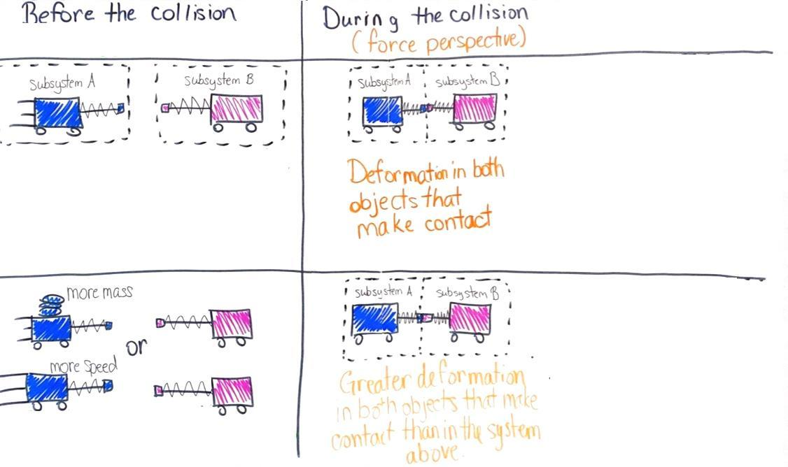
  Suggested prompt | Sample student response
  Are there any contact forces between subsystem A or subsystem B before they collide? | No.
  ADDITIONAL GUIDANCE | In Lesson 8 students will argue that there are actually contact forces acting on the moving cart subsystem before the collision. These will include friction and air resistance. But the way the system is currently defined, excluding the surrounding air and surfaces the carts are rolling over, is making reference only to the contact forces between the two cart subsystems. If students bring up these ideas, honor these ideas by asking students to add their questions to the Driving Question Board or by adding them to the class model by writing the idea and putting a question mark next to the term or idea.
  Say, We can represent the direction of that force on subsystem B with a straight arrow going to the right, and we can show the tip of the arrow on the end of the spring scale plunger to indicate that this is the surface which the contact force is pushing. Draw subsystem B on a separate piece of paper and tape it to the chart.. Add an orange force arrow pointing to the right, touching the end of the plunger. Label this as “Peak force on subsystem B”. | 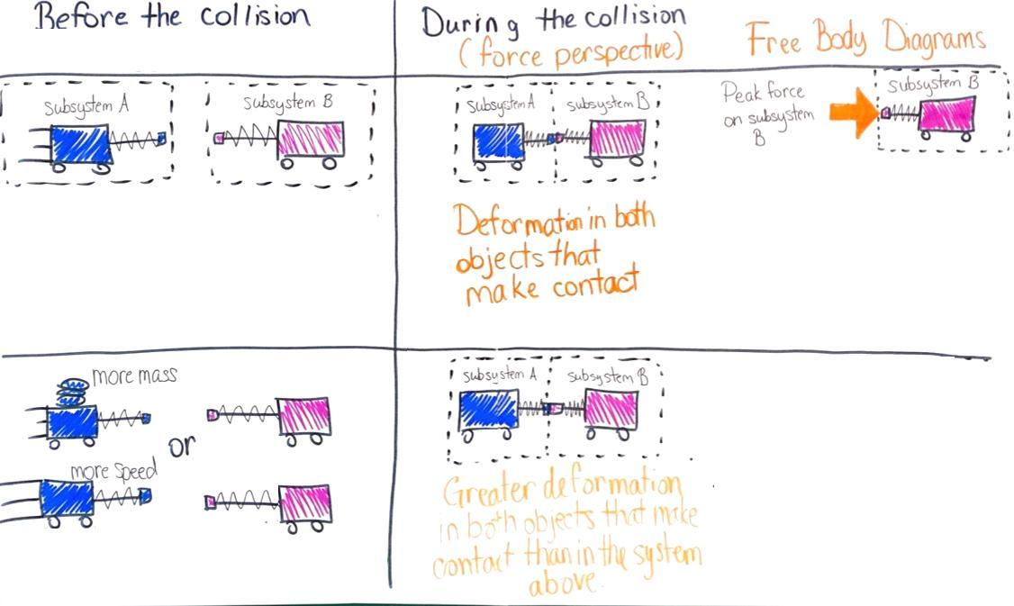
  Ask students what is pushing on subsystem A during the collision. Students should say the spring scale in subsystem B. Ask students to point in the direction that shows which way the force is pushing on subsystem A. Students should point to the left.  Ask how we can show that the strength of the force is the same on subsystem A as on B, but in the opposite direction. Students will say that we can use the same-sized arrow as before but facing the opposite way. Add the text “... is equal in strength to ...” and then draw subsystem A below it. Add an orange force arrow pointing to the left, touching the end of the plunger. Make sure it's the same size as subsystem B’s force arrow. Label this as “Peak force on subsystem A“. | 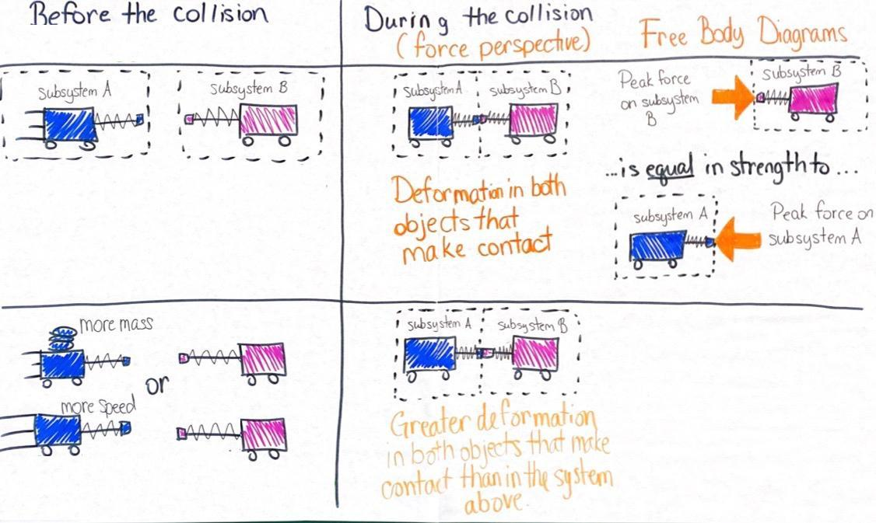
  Ask students how we can represent what we know happens to the peak forces on these two subsystems when we have more mass or more speed. Students will say that you can show this by including arrows on both.  Ask whether those arrows should be different sizes from each other or the same size and why. Students will say that they should be the same size to show that the forces are still equal.  Add these representations and related labels to the model as shown to the right. | 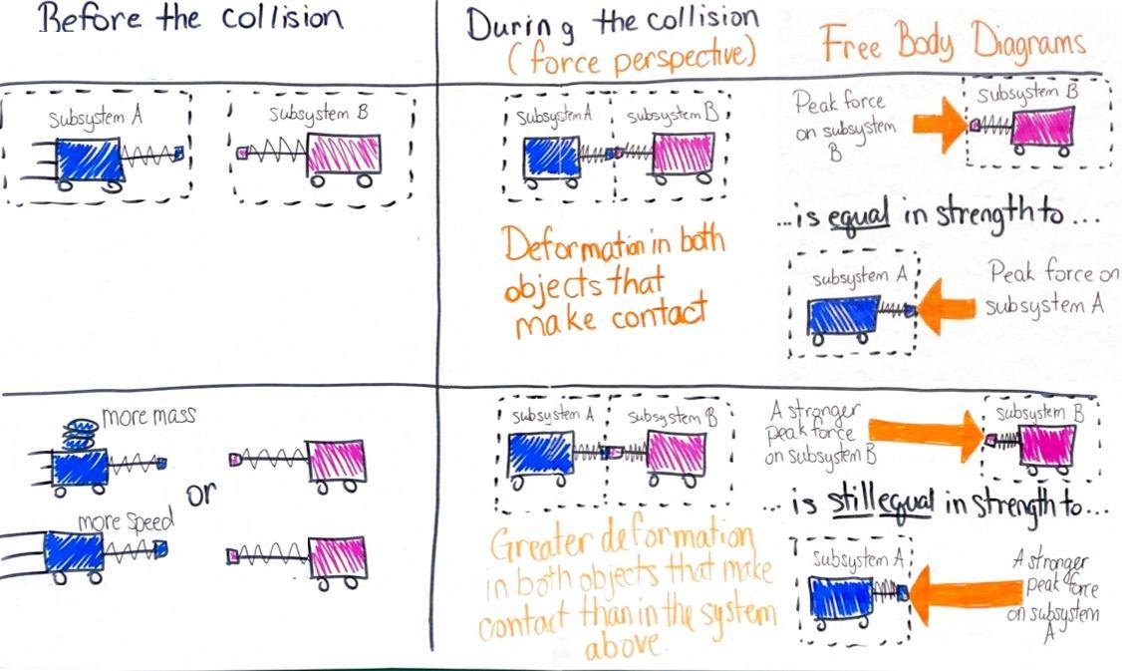
  Suggested prompt | Sample student response
  Before you carried out your investigations, neither cart subsystem was moving. At that point does either subsystem have kinetic energy? | No.
  If you hold one cart stationary and push and release the other cart to put it in motion, what parts of the system now have kinetic energy and which do not? | The cart (subsystem) you put into motion has kinetic energy.  The cart (subsystem) that is stationary does not have kinetic energy.
  What happens to the amount of kinetic energy the cart subsystem has when you increase its speed? | It has more kinetic energy.
  What happens to the amount of kinetic energy the cart subsystem has when you put it into motion at the same speed as before but with more mass? | It has more kinetic energy.
  Add “(energy perspective)” in green under the column head “Before the collision”. Ask students which part of the system shown in the top left cell of the table should be labeled as having kinetic energy. Students should say subsystem A has kinetic energy and subsystem B does not. Label this in the model in green.  Ask students how we would describe the relative amount of kinetic energy of subsystem A when it is going faster. Students should say it has more kinetic energy. Ask the same about when the mass is increased. Again students should say it has more kinetic energy. Label this in the model in green. | 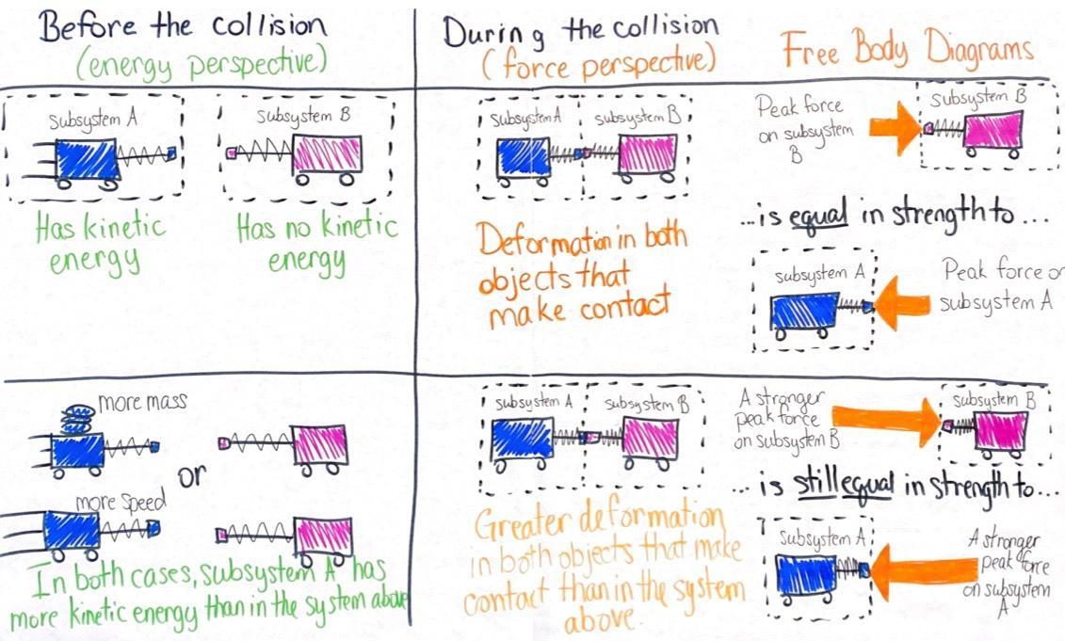
  Suggested prompt | Sample student response
  Our model shows that the mass and speed of a moving object influence its kinetic energy. What does our model show the relationship is between the amount of kinetic energy in the system and the peak forces between the objects in the system when they collide? | The more kinetic energy in the system the higher the peak forces will be between the objects in the system when they collide.
  ADDITIONAL GUIDANCE | In the case where both objects are moving in the same direction, this relationship doesn’t always hold. If both object A and object B are moving to the right and object A is catching up to object B, then any increase in the speed of object B that keeps the speed of object B less than that of object A will result in a collision between them that reduces the peak forces between them. This case is not one students will encounter in lesson activities in this unit and therefore not worth introducing.

12 · EXIT TICKET | 3 min
MATERIALS: science notebook, scrap paper
Refer to the model you developed to motivate testing the generalizability of these ideas in the upcoming assessment. Display slide N. Say, Since peak forces could either be weak enough to not exceed the elastic limit of the objects in a collision or be strong enough to cause permanent damage, it seems like we now have a chain of cause-and-effect reasoning that we can use to explain why some objects get damaged and others don’t in a collision. Let’s try to use this model to explain some of our initial collision-related phenomena as well as some new phenomena. Next time, you will have a chance to do that as part of a more-formal assessment opportunity. You will be able to use your notebook and you can use the consensus model we developed on this chart paper too as reference. Before we do that more-formal assessment, let’s complete a short exit ticket to check in on how you are thinking these ideas we developed would apply to something from our anchoring phenomenon.

ALTERNATE ACTIVITY | If time is short, you can administer this exit ticket as an entrance slip at the start of the next lesson. If you do that, it is suggested that you have students gather around the consensus model to kick off that task at the start of the next lesson.

ASSESSMENT OPPORTUNITY | Building towards: 5.B Develop and use subsystem models (free body diagrams) to represent how the peak contact forces on two different objects compare in a collision and how these are related to corresponding changes in the kinetic energy of a moving object before it collides due to an change in its mass or the speed.  What to look/listen for: Transferring the representations of the ideas developed in the class consensus model to a new context to explain a different phenomenon. The following ideas should be show up in students’ responses:  - A: Students identify one or both objects.  - B: The forces would be equal in strength.  - C: The kinetic energy would be less.  - D: The forces would be weaker but still equal in strength.  What to do: Review student exit tickets before Lesson 6. These can serve as a useful benchmark for whether students are ready for more-formal and extended assessment in that lesson. If students struggle with the ideas on this exit ticket, revisit the consensus model at the start of next class and ask those students to co-articulate what the representations in it show and how these could be used to explain what is happening in another collision scenario (e.g., the ball and the bat or the golf club and the golf ball).

